Dry Bath Incubator——DH100-1,DH100-2,DH100-4
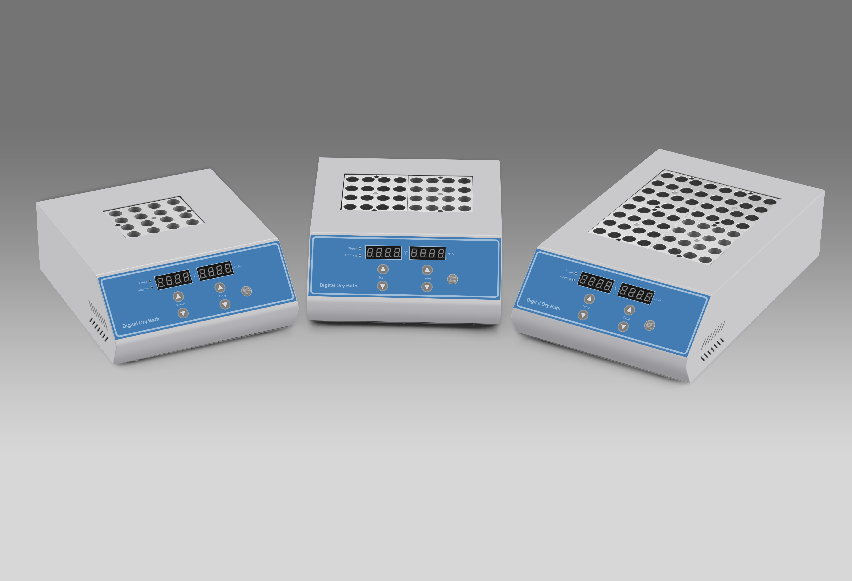
Description:
DH100 series high temperature dry bath incubator controlled by microcomputer, use high purity aluminum material as a heat conduction medium instead of the conditional water bath device. which is easy to use, wide temperature range, high precision and etc. It can be widely used in the sample preservation, reaction of DNA amplification, electrophoresis, degeneration, solidification and other kinds of serum biochemical sample thermostatic incubation process.

Features:
- Real-time temperature display, the countdown display.
- Convenient block replacement, easy to clean and disinfect.
- Automatic fault detection and alarm function
- Built-in over temperature protection device
- Temperature deviation calibration function
Parameters:
Model | DH100-1 | DH100-2 | DH100-4
Temperature range | RT.+5℃ ∼ 160℃ | RT.+5℃ ∼ 160℃ | RT.+5°C -130°C
Temp accuracy | ±0.5℃(@40℃) | ±0.5℃(@40℃) | ±0.5℃(@40℃)
Temp accuracy | ±1℃(@120℃) | ±1℃(@120℃) | ±1℃(@120℃)
Temp uniformity | ±0.5℃ | ±0.5℃ | ±0.5℃
Display accuracy | 0.1℃ | 0.1℃ | 0.1℃
Time range | 1min-99h59min/∞ | 1min-99h59min/∞ | 1min-99h59min/∞
Heating time | ≤15min(from 25℃ to 160℃) | ≤15min(from 25℃ to 160℃) | ≤20min(from 25℃ to 130℃)
Block quantity | 1 | 2 | 4
Max power | 300W | 500W | 600W
Voltage | AC220V or AC110, 50/60Hz | AC220V or AC110V, 50/60Hz | AC220V or AC110, 50/60Hz
Dimension(mm) | 260X220X100 | 260x220x100 | 360x220x100
Weight | 5.0kg | 5.5kg | 8kg

Optional Blocks:
Model | Tube Diameter | Capacity | Model | Tube Diameter | Capacity
MD01 | 6mm | 48 | MD10 | 26mm | 8
MD02 | 7mm | 48 | MD11 | 28mm | 4
MD03 | 10mm | 24 | MD12 | 40mm | 3
MD04 | 12mm | 24 | MD13 | 0.2ml centrifuge tube | 48
MD05 | 13mm | 24 | MD14 | 0.5ml centrifuge tube | 48
MD06 | 15mm | 16 | MD15 | 1.5ml centrifuge tube | 24
MD07 | 16mm | 16 | MD16 | 2.0ml centrifuge tube | 24
MD08 | 19mm | 12 | MD17* | 0.2ml PCR plate | 96
MD09 | 20mm | 12 | MD18* | 0.2ml Elisa plate | 96
*MD17 and MD18 is special for DH100-2/DH100-4

